Leander Haußmann, Herr Lehmann [Berlin Blues] (2003)

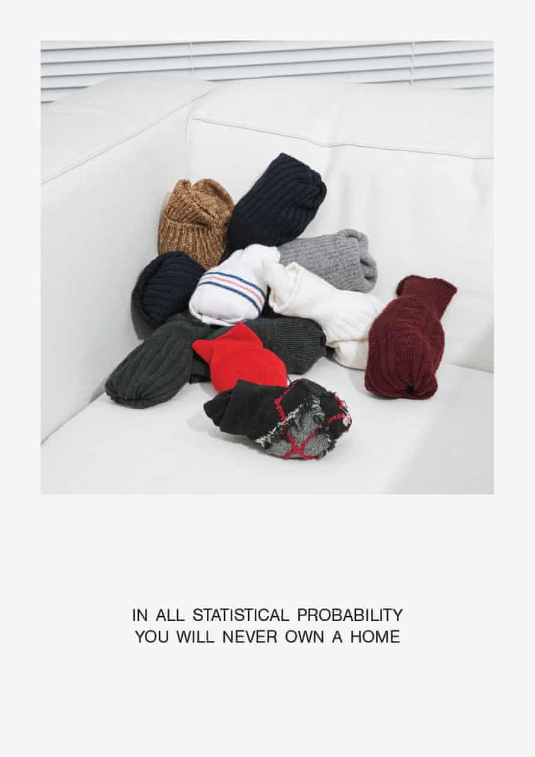

https://www.theguardian.com/artanddesign/2016/may/08/housing-curators-british-pavilion-venice-architecture-biennale-