**BCHE 341 Lab**

**Lab5: Isolation of Protein/Enzyme from Mushroom**

Cellobiases are part of a group of enzymes collectively known as cellulases that are actively being studied and produced for use in the biofuel industry. These enzymes are capable of breaking down cellulose, a complex macromolecular construct of sugar chains. The sugar can then be converted to ethanol by microbial fermentation. This ethanol in turn can be used alone in certain engines or in combination with gasoline to power car, truck and airplane engines. Cellobiases are naturally produced by fungi and bacteria present in ruminants, termites, and some plants or plant products.

The enzyme cellobiase is used to increase the degradation rate of a sugar compound p-nitrophenyl glucopyranoside to glucose and p-nitrophenol which is a yellow substance.

The substrate p-nitrophenyl glucopyranoside is composed of a beta glucose covalently linked to a molecule of nitrophenol. When the bond connecting these two molecules is cleaved with the help of cellobiase, the p-nitrophenol is released. To stop the activity of the enzyme and to create a colored product, the reaction mixture is added to a basic solution. When the p-nitrophenol is placed in a basic solution, the hydroxyl group on the nitrophenol loses an H+ to the OH– of the base, which changes the bonding within the phenolic ring, so that the molecule will absorb violet light (and reflect yellow light). This makes the solution yellow, which can be detected visually by comparing the deepness of the yellow color to a set of standards of known concentration of p-nitrophenol or by using a spectrophotometer to produce more accurate, quantitative results. The enzyme activity is indirectly measured by monitoring the change in color intensity of the solution.

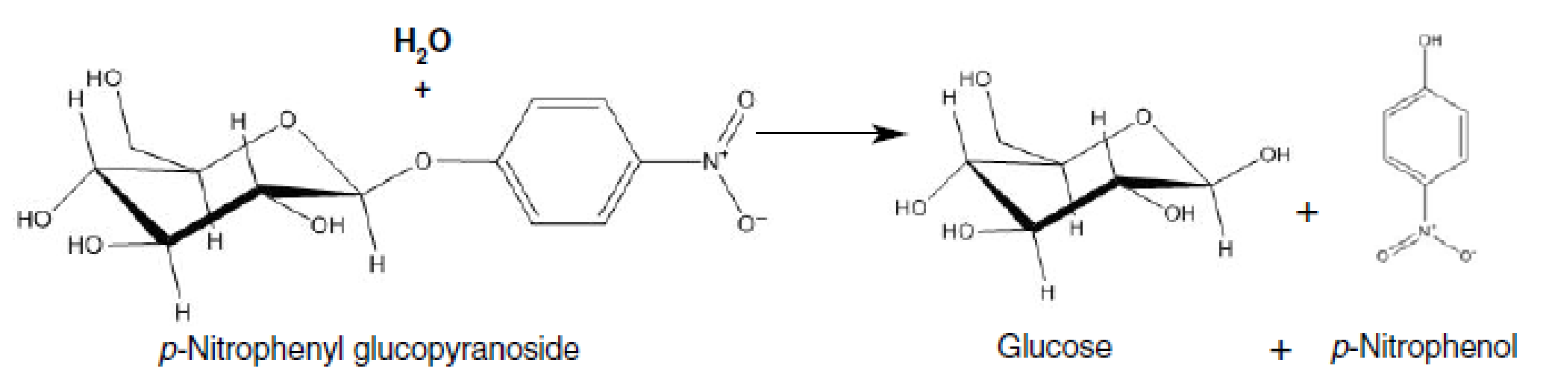

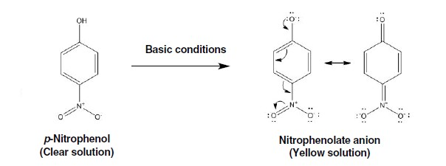

**Protocol:**

**Protocol**

1. Write down the name of your mushroom Portobello
2. Carefully remove stem
3. Cut through center of the cap of mushroom. In case if cap is not distinguishable cut through meatiest section.
4. Weigh out approximately 1 g of your mushroom and place it in a mortar. 1.107 g
5. Add 2 ml of extraction buffer for every gram of mushroom into the mortar. 2 ml.

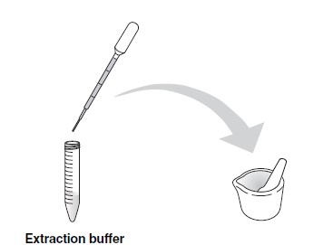

1. Using a pestle, grind your mushroom to produce a slurry.
2. Strain the solid particles out of your slurry using a piece of filter paper or cheese cloth into a 1.5 ml microcentrifuge tube. Alternatively, if you have a centrifuge, scoop the slurry into a 1.5 ml microcentrifuge tube and then pellet the solid particles by spinning at top speed for 2 minutes.

**Note**: You will need at least 250 μl of extract to perform the enzymatic reaction.

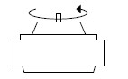

1. Label your cuvettes “1–7”. Only label on the upper part of the cuvette face.

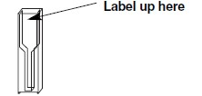

1. Using a clean transfer pipette(TP), pipet 500 μl of stop solution into each cuvette. Rinse out the TP thoroughly with water.

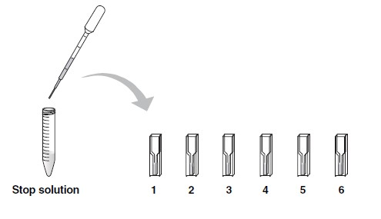

1. Label a 15 ml conical tube with the type of mushroom you are using. Using a clean TP, pipet 3 ml of substrate into the tube.

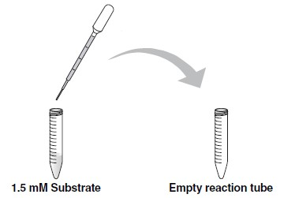

1. Using same TP from previous step, add 450uL of substrate and 50uL of extraction buffer to cuvette#7 and set it aside for analysis later on. This cuvette will act as a control during your investigation because it does not contain mushroom extract.

**Please read and understand steps 12–14 fully before proceeding. These steps are time sensitive!**

1. Using a clean TP, pipet 250 μl of your mushroom extract into the 15 ml conical tube containing 3 ml of substrate. This will be referred to as the **Reaction tube.** Pipet up and down to mix. Then pipet 500uL from 15ml conical tube to cuvette #1. **START YOUR TIMER**.

1. At the times indicated, use the TP labeled “E” to remove 500 µl of the solution from the “Enzyme Reaction” tube and add it to the appropriately labeled cuvette containing the stop solution.

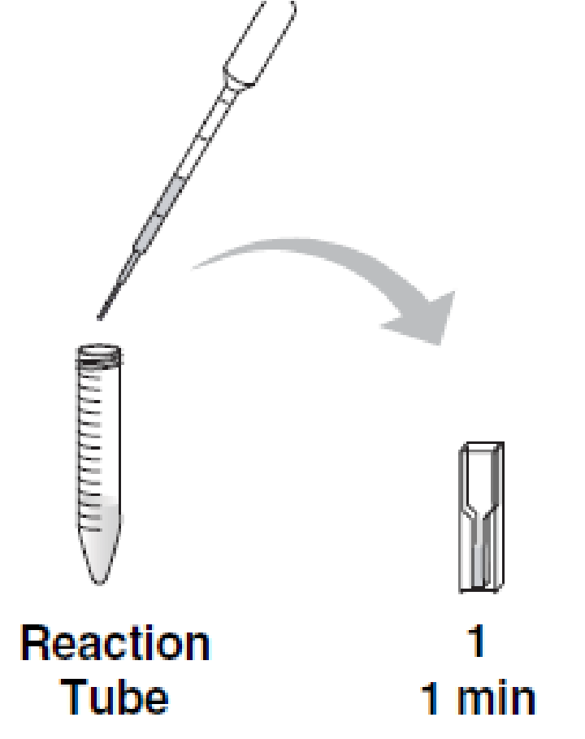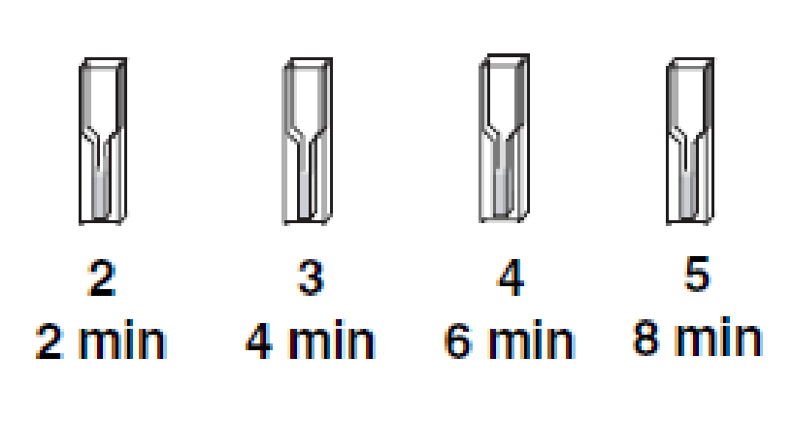

1. Proceed with the analysis of your samples. After you have finished your analysis, rinse out the reaction tubes, cuvettes, and TPs with copious water and save them for later activities.

Making of p-Nitrophenol standards:

1. Solution S5 is provided with 100nmol of p-Nitrophenol(pNP)
2. Make 1ml solutions of 0,12.5,25,50nmol of pNP, using S5 as stock solution.

|  |  |  |  |
| --- | --- | --- | --- |
| Standard | Concentration(nmol) | Amount of S5 | Amount of ddI water |
| S1 | 0 |  |  |
| S2 | 12.5 |  |  |
| S3 | 25 |  |  |
| S4 | 50 |  |  |
| S5 | 100 | 1ml | 0 |

1. Label 5 cuvettes from S1-S5.
2. Put 1ml of standards in each cuvette and analyze at 410nm using UV-Vis spectroscopy

**Post lab Questions:**

1. Why is the absorbance of 410nm used to analyze the reaction taking place in the cuvette? Name the final products formed.

1. Fill the table for the values observed for Standard solutions:

This table below includes the information for the p-Nitrophenol standards, and you will need to graph these numbers.

|  |  |  |
| --- | --- | --- |
| Standard | Concentration(nmol) | Absorbance (410nm) |
| S1 | 0 | 0.002 |
| S2 | 12.5 | 0.176 |
| S3 | 25 | 0.380 |
| S4 | 50 | 0.768 |
| S5 | 100 | 1.482 |

1. Make a standard curve for the above standards and paste it here once completed in Excel.

1. Determine the concentration of unknown amount of pNP from graph. Show the data points in your previous graph

|  |  |  |  |
| --- | --- | --- | --- |
| Cuvette | Time(mins) | Absorbance at 410nm | pNP produced(nmol) |
| 1 | 0 | 0.369 |  |
| 2 | 1 | 0.492 |  |
| 3 | 2 | 0.523 |  |
| 4 | 4 | 0.664 |  |
| 5 | 6 | 0.885 |  |
| 6 | 8 | 1.035 |  |
| 7 Control | 8 | 0.002 |  |

1. Why is standard curve important?

1. What is importance of a control?