|  |  |  |  |
| --- | --- | --- | --- |
|  | **10.4.3 Lab: Optics** | | Dry Lab |
| Physics | Name: |  |
| Date: |  |

# **Optics**

Materials:

* Optics bench
* Optics kit, including a lens/mirror mount
* Convex lens of known focal length
* Concave mirror of known focal length
* Light source/candle
* Screen
* Meter stick/metric ruler
* Two polarized films
* Prism
* Laser pointer
* Protractor
* Graph paper
* Electromagnetic spectrum chart

Materials for Exploring Further:

* Plane mirror
* Ripple tank, with sheet of plastic or glass that fits on part of the bottom of the tank, and objects that can be used as boundaries to obstruct the pathway of waves
* Wave-motion rope
* Tuning-fork kit
* Stroboscope
* Resonance-tube kit

In this lab, you will investigate the relationship between the focal lengths of a mirror and lens and the type of image that is generated.

**Procedure**   
  
**Part 1: Image from a Lens**   
  
1. Place the light source, convex lens, and screen on the optics bench as shown in figure 1. Start with the light source at a distance greater than 2ƒ from the lens.

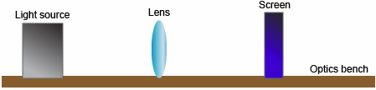

Figure 1

2. Measure the height of the light source, or "object" (*ho*), and record it in data table 1. Also measure and record the distance between the lens and the light source (*do*) in the data table. Using the lens equation and the given focal length, calculate the distance from the lens to the image (*di*) and the height of the image (*hi*): and .  
  
Record your calculations in the "Calculated" section of data table 1.   
  
3. Keeping the light source and lens in the same position, turn on the light source and adjust the screen until a clear, real image is formed on the screen. Measure the experimentally determined *di* and *hi*, and record your observations in the "Experimental" section of data table 1.  
  
4. Place the light source a distance of exactly 2ƒ from the lens. Record the distance between the lens and the light source (*do*) in data table 1. Using the lens equation and the given focal length, calculate the distance from the lens to the image (*di*) and the height of the image (*hi*). Record your calculations in the "Calculated" section of data table 1.  
  
5. Turn on the light source, keeping it 2ƒ from the lens, and adjust the screen until a clear, real image is formed on the screen. Measure the experimentally determined *di* and *hi*, and write your observations in the "Experimental" section of data table 1.  
  
6. Place the light source at a distance of somewhere between ƒ and 2ƒ from the lens. Record the distance between the lens and the light source (*do*) in the data table. Using the lens equation and the given focal length, calculate the distance from the lens to the image (*di*) and the height of the image (*hi*). Record your calculations in the "Calculated" section of data table 1.  
  
7. Keeping the light source and lens in the same position, turn on the light source and adjust the screen until a clear, real image is formed on the screen. Measure the experimentally determined *di* and *hi*, and write your observations in the "Experimental" section of data table 1.   
  
**Data Table 1**

|  |  |  |  |  |
| --- | --- | --- | --- | --- |
| ***ho* = 1.5 cm**  **ƒ = 25 cm** | **Calculated** **results** | **Calculated** **results** | **Experimental** **results** | **Experimental** **results** |
|  | ***di*** | ***hi*** | ***di*** | ***hi*** |
| Greater than 2ƒ ***do* = 54 cm** |  |  | 46.4 cm | 1.3 cm |
| 2ƒ ***do* = 50 cm** |  |  | 49.5 cm | 1.4 cm |
| Between ƒ and 2ƒ ***do* = 42 cm** |  |  | 61.5 cm | 2.1 cm |

**Part 2: Image from a Mirror**   
  
8. Repeat steps 1 - 7, this time using the concave mirror. Be sure to angle the mirror to project the image onto the screen, as shown in figure 2. Record your calculations and measurements in data table 2.

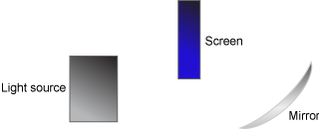

Figure 2

**Data Table 2**

|  |  |  |  |  |
| --- | --- | --- | --- | --- |
| ***ho* = 1.5 cm**  **ƒ = 25 cm** | **Calculated** **results** | **Calculated** **results** | **Experimental** **results** | **Experimental** **results** |
|  | ***di*** | ***hi*** | ***di*** | ***hi*** |
| Greater than 2ƒ ***do* = 60 cm** |  |  | 43.1 cm | 1.2 cm |
| 2ƒ ***do* = 50 cm** |  |  | 48.5 cm | 1.5 cm |
| Between ƒ and 2ƒ ***do* = 46 cm** |  |  | 54.5 cm | 1.8 cm |

**Part 3: Observing Polarization and Refraction**   
  
9. Place a polarized film over the light source. Place another polarized film on top of the first. Slowly turn the second film while keeping the first film stationary. Notice what happens to the brightness of the light.  
  
10. Remove the polarized films. Place a prism over the light source. Turn the prism until you can see a rainbow.   
  
11. Direct a laser pointer toward the prism at an angle, as shown in figure 3. Trace the shape of the prism on a piece of paper.  
  
12. Trace the path of the laser through the prism.   
  
13. Remove the prism and use a protractor to measure the angle of incidence and the angle of refraction. The angle measurements are recorded for you here:   
  
Angle of incidence: 45°  
  
Angle of refraction: 30°

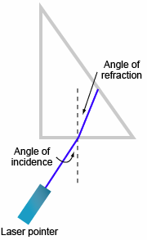

Figure 3

**Analyze**

1. What happens to the height of the image (*hi*) formed by a convex lens as the object moves closer to the lens?

2. What happens to the distance from the image to a convex lens (*di*) as the object moves closer to the lens?

3. How do the calculated results compare with the experimental results for the lens and mirror experiments?

4. Create a graphic organizer to show the different images created by the convex lens and concave mirror.

5. In part 3, what happened to the brightness of the light when you put the polarizing filter over the light source? What happened to the brightness as you turned the filter?

6. In part 3, describe what was happening to the light as it passed through the prism.

7. In part 3, the laser pointer used for the experiment was red. Consult an electromagnetic spectrum chart. What does the color of the laser tell you about the relative frequency of the visible light in the laser? What does the color tell you about the relative wavelength of the visible light in the laser?

**Draw Conclusions**

1. How do the images formed by the concave mirror compare with the images formed by the convex lens?

2. What kind of image, real or virtual, is formed by the concave mirror in this experiment? How do you know?

3. In part 3, how does the incident angle (angle in air) compare with the refracted angle (angle in prism)?

**Explore Further**

1. Imagine you moved the object to a distance closer than *f* from the lens, and tried to find the image on the screen. Why can’t you find a clear picture? Where is the image?

2. How would you refine this experiment to use a plane mirror and observe its image? What kind of image does a plane mirror make?

3. **Observing Waves in a Ripple Tank**   
  
CAUTION: Be careful about any spills as you complete this activity. Have a mop handy.  
  
Set up a ripple tank with a wave generator on one side. Turn on the wave generator. Place a boundary in the middle of the ripple tank. What happens to the waves when they hit the boundary?

Remove the boundary. Place a flat piece of plastic or glass on the bottom of one side of the tank so that it is completely submerged. What happens to the waves when they pass from the deeper water to the shallower water?

Remove the plastic or glass. Now place two boundaries in the middle of the tank so that there is an opening between them. What happens to the waves as they pass through the opening?

4. **Observing Wave Motion in a Wave-Motion Rope**   
  
Set up a wave-motion rope, as shown in figure 4. Either attach one end to a fixed object or have someone hold it. Quickly raise and lower the rope to send a pulse. What happens to the pulse when it hits the other end of the rope?

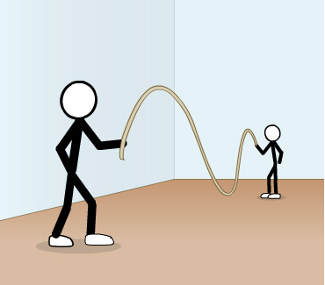

Figure 4: Using a wave motion rope

5. **Observing Frequency**   
  
Sound a variety of tuning forks. Each fork is labeled with its frequency. What is the relationship between the length of the tuning fork and the frequency of its sound? What is the relationship between the frequency and the pitch of the note?

Turn off all the lights in the room and strike a tuning fork. Turn on the stroboscope and adjust the frequency so that the tines of the fork look like they are moving slowly. What is the tuning fork doing to create a sound?

Sound a variety of resonance tubes. The frequency of each tube is found on the side of the tube. What is the relationship between the length of the tube and the pitch of the note it plays?

Copyright © 2019 Apex Learning Inc. Use of this material is subject to Apex Learning's [Terms of Use](http://www.apexlearning.com/Terms_of_Use_Customer_Websites.htm). Any unauthorized copying, reuse, or redistribution is prohibited. Apex Learning ® and the Apex Learning Logo are registered trademarks of Apex Learning Inc.

10.4.3 Lab: Optics