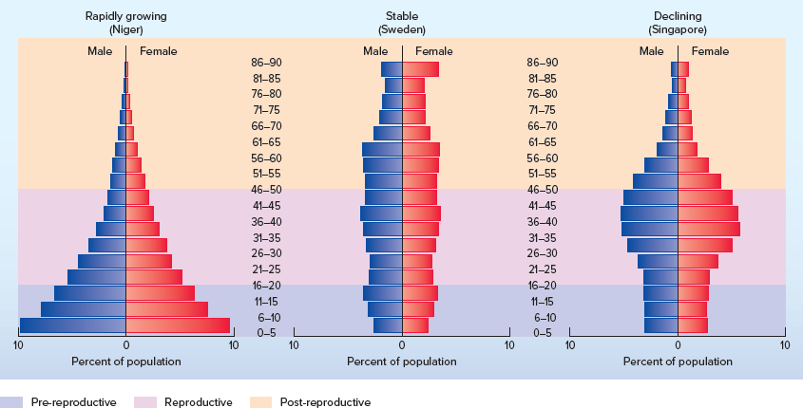
This is a of an age structure document required to be included for this assignment. Using CANADA, of course! Note: please use two of the countries above plus that of Canada’s. Choose ones that contrast with Canada’s age profile. Thank you.

